**Task 1: Conditional Column - Categorize Discount Levels**

**Objective:**

Create a new column: Discount Category

* High Discount → Discount > 0.3
* Medium Discount → Discount between 0.1 and 0.3
* Low Discount → Discount < 0.1

**Task 2: Column from Examples – Extract Year from Order Date**

**Objective:**

Extract Order Year using Column From Examples.

**Task 3: View Column Quality & Distribution**

**Objective:**

Analyze column health.

**Task 4: Create a Star Schema Model**

**Objective:**

Design a Star Schema from the Orders fact table.

**Task 1: Conditional Column - Categorize Discount Levels**

**Objective:**

Create a new column: Discount Category

* High Discount → Discount > 0.3
* Medium Discount → Discount between 0.1 and 0.3

Low Discount → Discount < 0.1

Using add column, we can do it. Using below formula.

= Table.AddColumn(#"Changed Type", "Discount Category", each if [Discount] >=0.3 then "High Discount" else if [Discount] <0.3 and [Discount]>=0.1 then "Medium Discount " else "Low Discount ")

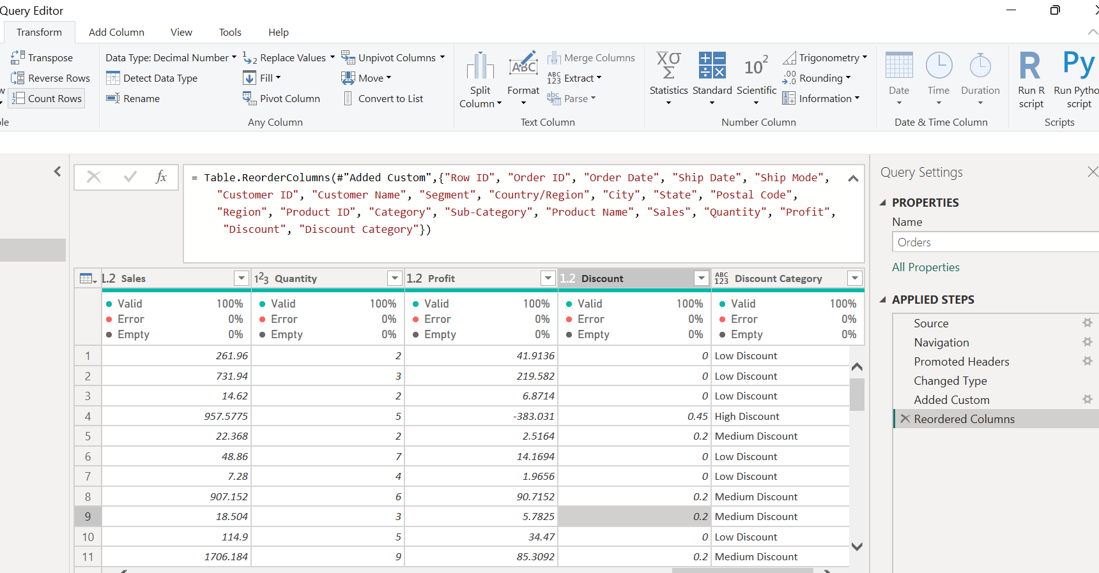

Other way of doing same task using column example  
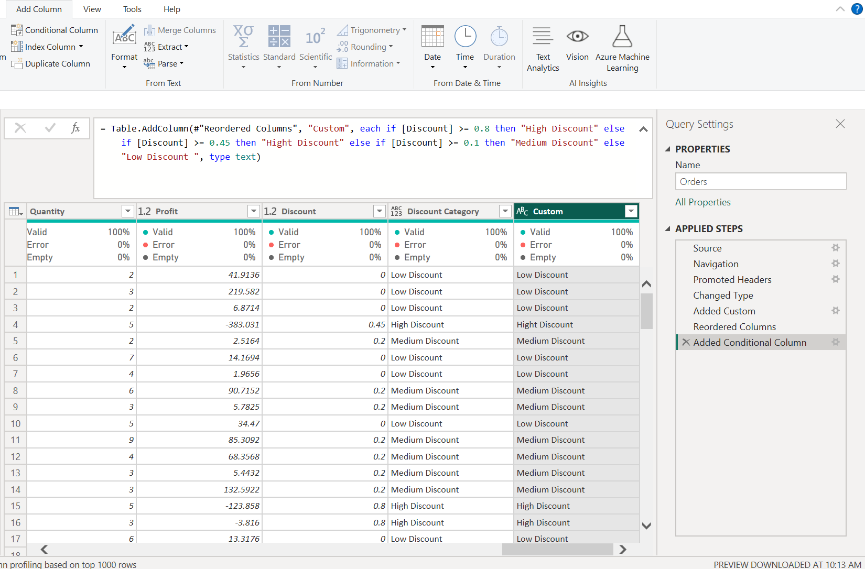

**Task 2: Column from Examples – Extract Year from Order Date**

**Objective:**

Extract **Order Year** using Column From Examples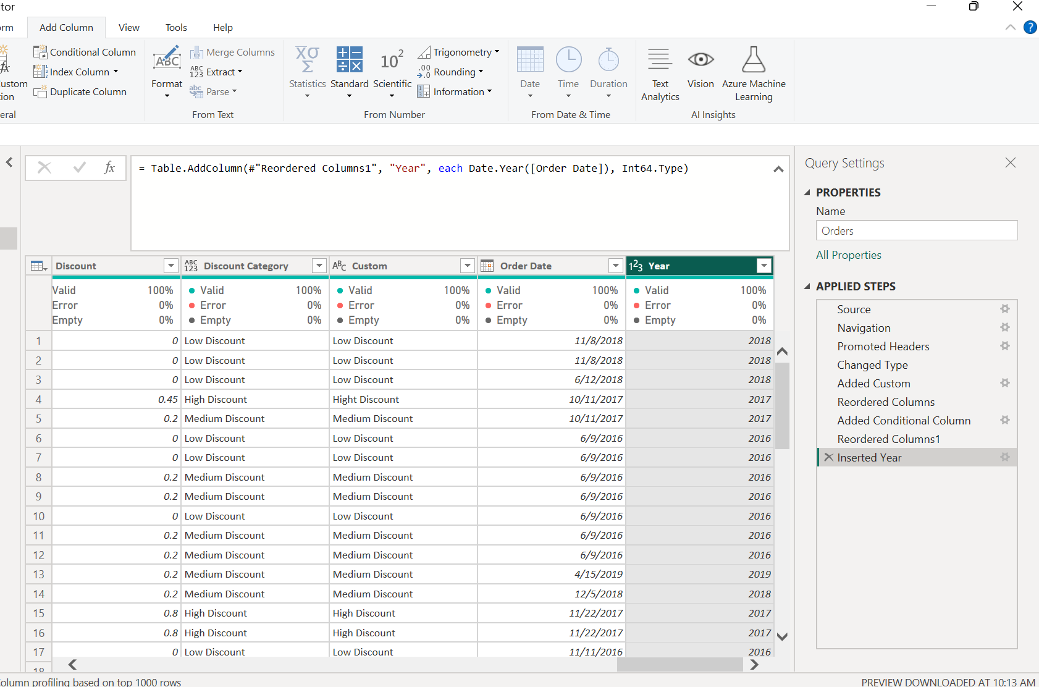

**Task 3: View Column Quality & Distribution**

**Objective:**

Analyze column health.

**Task 4: Create a Star Schema Model**

**Objective:**

Design a Star Schema from the Orders fact table.

Ans:-  
In this dataset fact table is Orders  
Dimension table is customer,product,